Cut Off Machine Safety Tips
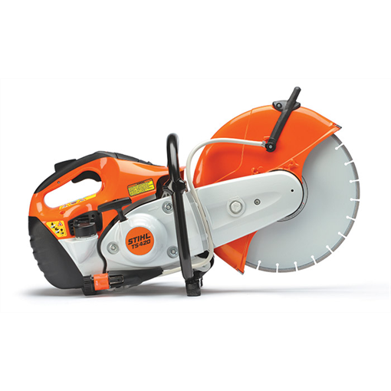
(Chop Saws and Chain Saws)
They are handy tools when you use them right

If you work with any kind of pavement or masonry, you probably use this kind of tool. It’s handy, tough, and reasonably priced for the work it does. And it’s actually a SAFE tool to use, when you understand its’ properties. Unfortunately, it is involved in a lot of worker fatalities and injuries each year. Amputations and what’s called ‘avulsion lacerations’ are common injuries. Fatalities are rare but they do occur.
The machine builder understands the potential the saw has for causing problems. One prominent maker even publishes a separate Safety Manual for their tool, free on the internet. It probably does not get a lot of readership, since most of the trades using the saw consider themselves already to be ‘experts’ with the tool already. Mostly because they have not had an accident. Yet. In other words, a ‘know it all’ mentality pervades the use of the tool. That’s probably the biggest obstacle, and pretty darned easy to address. Here are the operative factors:
- Hold some kind of ‘task training’ or a safety class. This training is fairly straightforward if you basically just review the Operators Manual or the Safety Manual. A ‘Qualified Person’ can do the training, the most basic form of which is looking at the pictures in the manual showing good and bad practice. Document that you held the training. Proof of training will come in handy if there is an ‘Incident Investigation’.
  - Bilingual, non? Si senor Google, el libro es en Espanol, libre, en internet. Translation: you have no valid excuse to do the training. It should take all of an hour.
  - Safety Lesson ONE: NEVER stand directly behind the saw. (Ditto for chain saws)
- A lot of problems occur when trying to use the saw ‘out of position’. We had a fatality a couple years ago when a mason tried to hold the saw at shoulder height, sideways, jamming it into a column trying to make a small cut. Sure enough, the saw bound, kicked back and essentially cut his throat. There is no real first aid for this kind of injury. He could have used a 4 in. angle grinder instead, but the big saw was the only tool handy. Keep the saw at waist level as much as possible. Avoid raising it higher as this will sacrifice user control.
- Support or stabilize the piece being cut. This is one of the basic rules of cutting or drilling. On a drill press you have a table and usually a vise. On a muddy job site installing concrete pipe, you need to improvise. The proper technique will depend on what and where you cut, but a common practice is to make partial cuts, such as around the circumference of a pipe, leaving supporting uncut sections. When you complete the periphery, make the last slices under control to complete the cut. The piece should not ‘drop’ so much as ‘separate’ under control. Use wedges to prevent pinch type binding which can cause uncontrollable kick back
- Wear your PPE. Most of the trades have the brains enough to wear at least safety glasses. The full complement should rightfully include much more, but you don’t have time for all that baggage, correct? OK, you bear the risk of catastrophic result, which the ER doc will surely ask why you weren’t wearing say, gloves.
- Dust control. This is often a nuisance and real men don’t use water to keep the blade cool anyway. Occupational silica dust exposure when combined with cigarette smoking will pretty much guarantee your use of an oxygen hose to supplement lost lung capacity, if you even make it to retirement. Use the hose or water spray attachment on the saw. When you break the nozzle, go to the hardware store and buy a pump sprayer. Or at least make the cut in an area where the dust will disperse and not create a mess for everyone else. Buy a wet-vac to suck up the slurry. OSHA is going to be looking for dust clouds: they just revised the Silica Dust Exposure Standard to a fraction of what it formerly was. The ‘L’ word will no longer apply. (Too LAZY to hook up a hose.)
- Control The Exposure – that term sounds like a stretch to most trades, but what it translates to is: to designate one or two people exclusively to use the saw. Train and equip these persons as your designated sawyers. They’re the ‘specialistas’. Otherwise, every mason on the job will have an ‘incidental exposure’ to this very powerful tool. Human nature tells us that some users will observe a few of the safety rules, but many will not. ‘Just cut the thing’ is the operative terminology. Restrict the use of the saw to the best handlers.
- Set up a radial wet table saw in a central area. Set up a pivoting chop saw. Use other cutting methods. Think. How can we best organize and stabilize this process? If you do figure out how to set up a central cutting station, make sure you have adequate LIGHTING, good housekeeping all around the saw, some type of drainage or run off control for the slurry (i.e. wet-vac or tray)
- Plan your work. For example, you know you will need quarter or half-blocks on a wall, or specialty shapes according to plans. Cut as much in advance, at the shop for example, to minimize the extra labor on the site. Specialty miters, circular, holes, other odd shapes? Do your homework. You are not typically going to be building museums, so the detail does not need to be microscopic. In other words, make some intelligent adjustments to the production process aimed at minimizing use of the cut off saw and speeding things up by skipping the ‘custom cut’.
- Cut the pipe (or other awkward pieces) off site or in a staging area, where you can properly stabilize the work. Cutting everything at ground level puts you at an ergonomic disadvantage right off the bat. Upper body strength is a big player in safe saw handling. This decreases when you are bending, stooping or otherwise out of the optimal strength zone centered at your waist. The floor or ground is a poor working surface. A basic indicator of professionalism is staying off the dirt.
- Select the best cutting blade for the application: all-purpose, diamond, other specialty. You make the call. Re-bar, concrete pipe, asphalt, masonry, stone, tile, rusty tin, fence posts, cast iron, steel angle iron, etc. Most abrasive blades are durable and relatively cheap. The one material that rotary saw is not made to cut is LUMBER. If you need to slice two x fours, get a circular saw or miter saw or other tool designed for it. Cutting lumber or wood is basically asking for trouble, as we recently learned on a job site. The docs were able to reattach the lower leg, but a simple battery powered Milwaukee tool kit would have avoided the mess in the first place.
Summary: If you truly want to call yourself a professional, you will understand that bringing one tool on the site and expect to do all your cutting with it, is very narrow thinking. Gear up for the work at hand and spend the extra few bucks on the best tool inventory for your job. There is another tool called a “JHA” (shorthand for JOB HAZARD ANALYSIS) that is actually your ‘all-time best ever’ safety device. But that dissertation will have to wait for the next installment.

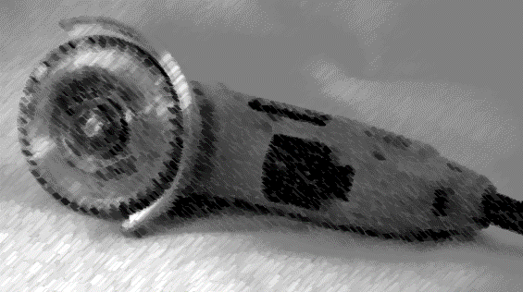

John J. Meola, CSP, ARM, is the Safety Manager for Pillar, Inc. based in Richmond, VA. He provides safety consulting and training to companies across the US. Meola specializes in teaching safety and developing programs where there are no clear regulatory standards. Not surprisingly, this covers a lot of industry. He can be reached at jmeola@pillarens.com.

